Dear Candidate,

Process to start your Collaborative Assessment at WiseTech Source.

1. **Login to WiseeApp using your Login Id and Password**
2. **Go to Programs -> e-Assessment**
3. **Click on View button**

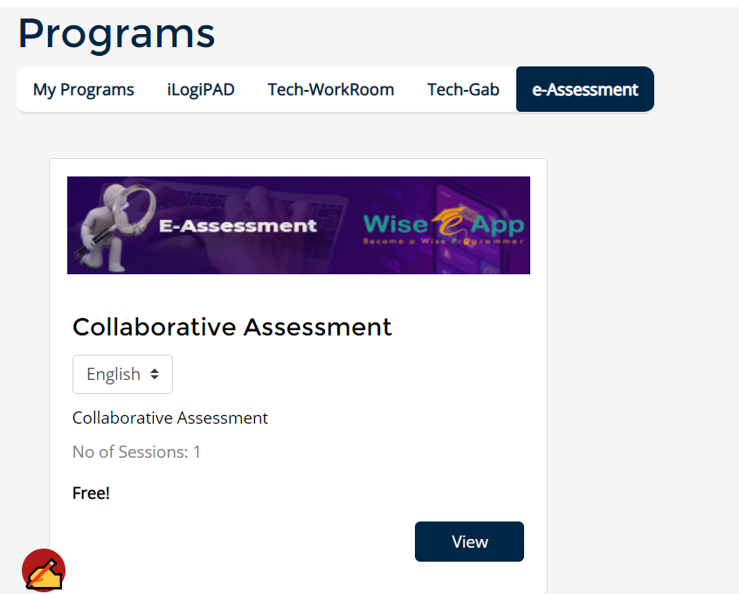

1. **Click on Assessment Tab & Click Scenario**

